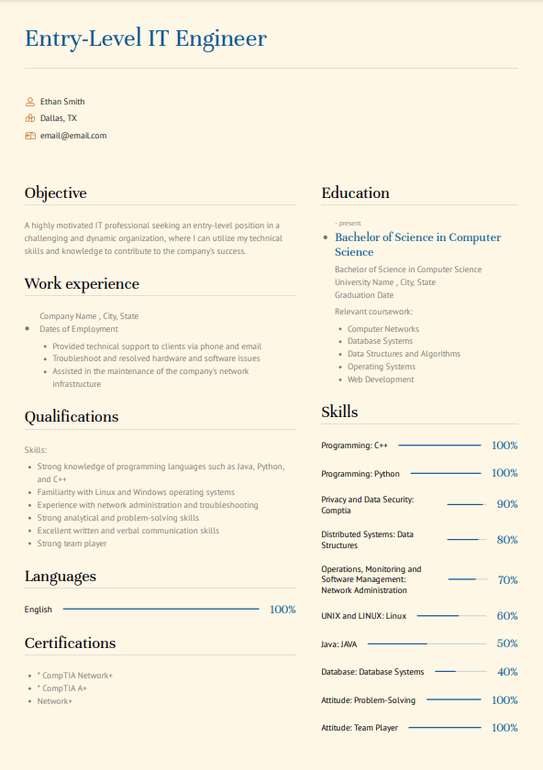
Entry-Level IT Engineer
Ethan Smith
Dallas, TX
email@email.com
Objective
A highly motivated IT professional seeking an entry-level position in a challenging and dynamic organization, where I can utilize my technical skills and knowledge to contribute to the company's success.
Work experience
Company Name, City, State
• Dates of Employment
• Provided technical support to clients via phone and email • Troubleshoot and resolved hardware and software issues • Assisted in the maintenance of the company's network
infrastructure
Education
•
present
Bachelor of Science in Computer Science
Bachelor of Science in Computer Science
University Name, City, State
Graduation Date
Relevant coursework:
• Computer Networks
• Database Systems
• Data Structures and Algorithms
• Operating Systems • Web Development
Skills
Qualifications
Skills:
Programming: C++
100%
• Strong knowledge of programming languages such as Java, Python, and C++
Programming: Python
100%
• Familiarity with Linux and Windows operating systems
• Experience with network administration and troubleshooting
• Strong analytical and problem-solving skills
• Excellent written and verbal communication skills
• Strong team player
Languages
Privacy and Data Security: Comptia
90%
Distributed Systems: Data Structures
80%
Operations, Monitoring and
Software Management:
70%
Network Administration
English
100%
UNIX and LINUX: Linux
60%
Certifications
*CompTIA Network+
• * CompTIA A+
• Network+
Java: JAVA
50%
Database: Database Systems
40%
Attitude: Problem-Solving
100%
Attitude: Team Player
100%

